**Set Up Email Notifications for CloudWatch Alarms using CloudWatch Log Groups and CloudTrail**

Step1:

Go to Cloud trial and create a trial

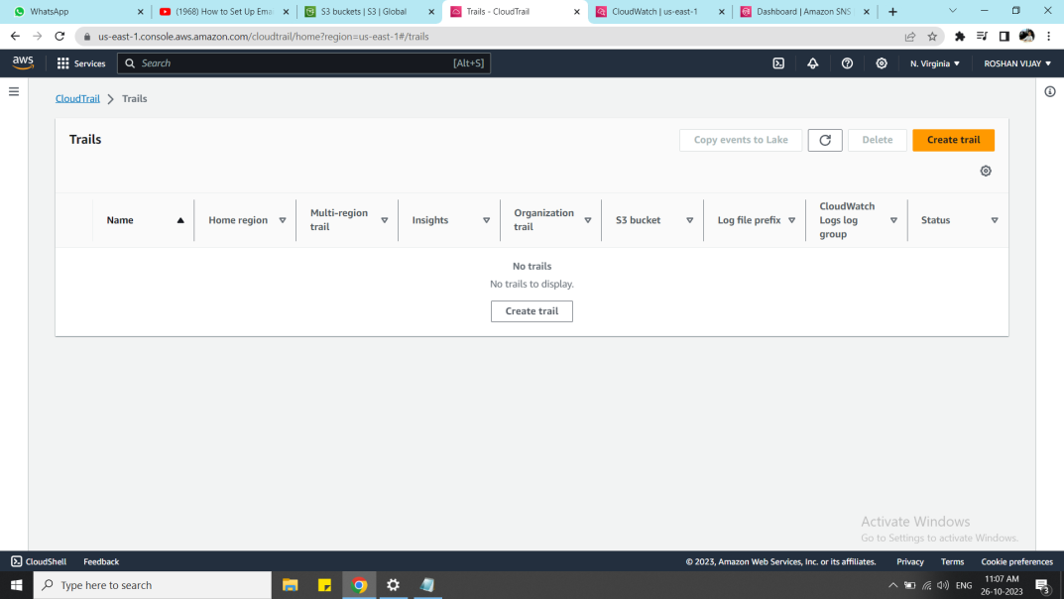

Step 2:

In storage location select create a new s3 bucket and disable the log file SSE-KMS encryption

and enable the log file validation

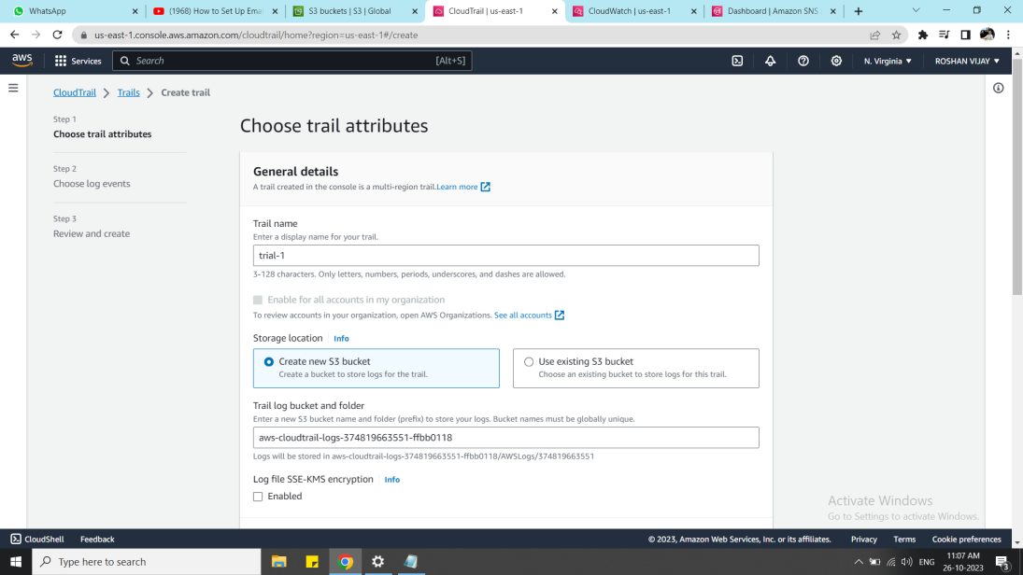

Step 3:

In IAM role ,create a new role and give the name to the role and click next

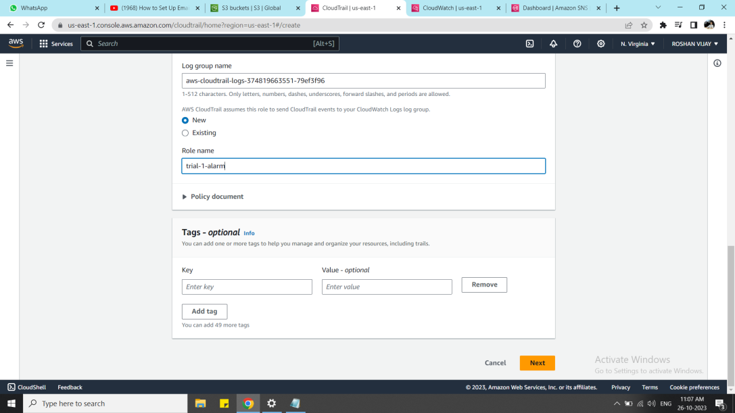

Step 4:

In the choose Log events tab, select the event type as Event and click next

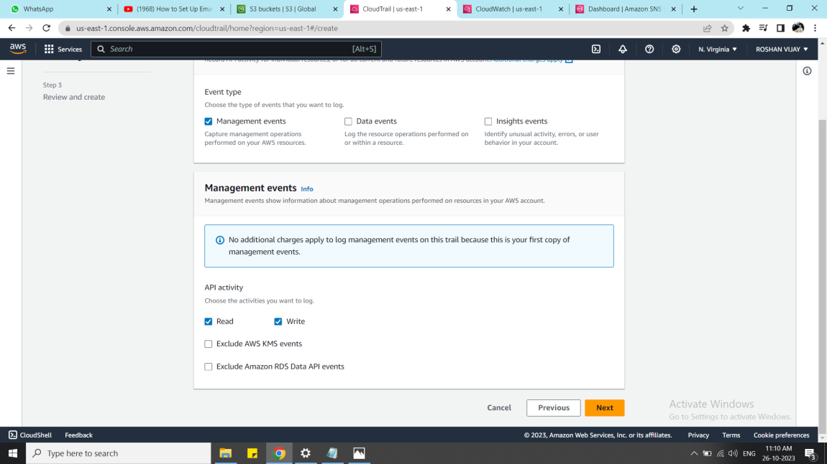

Step 5:

Review and create the Cloudtrial log

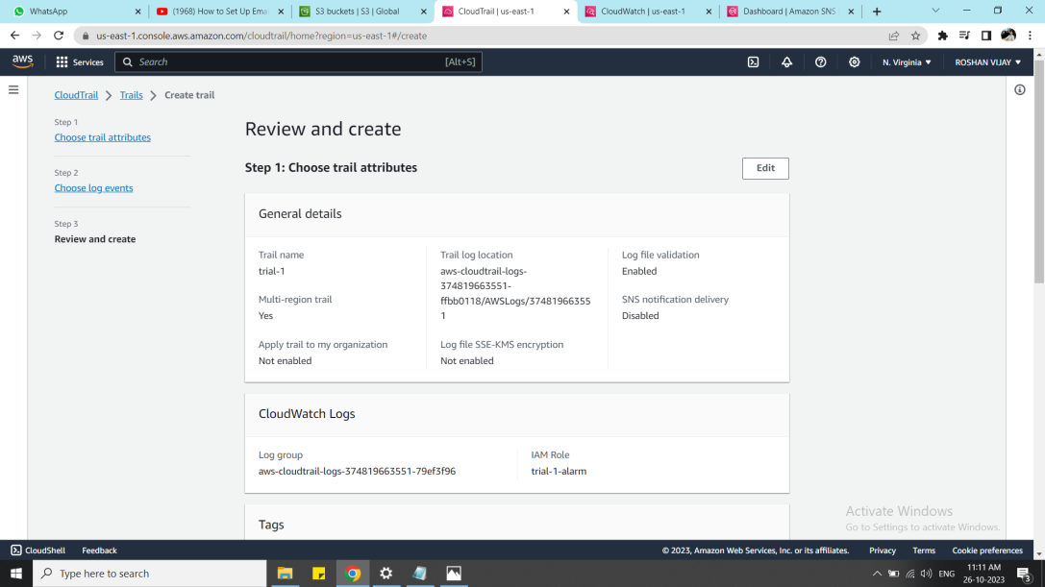

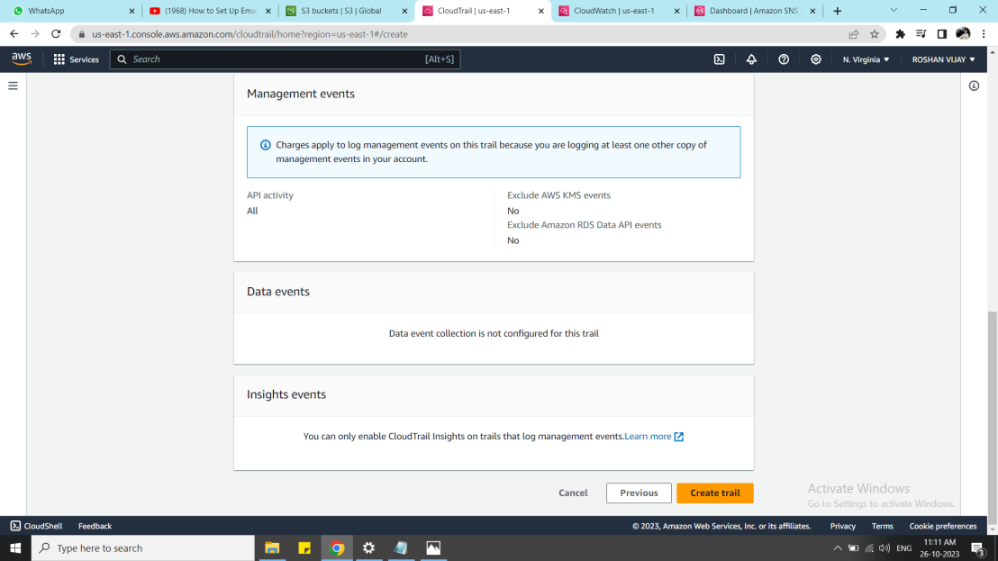

Step 6:

Now a new s3 bucket is created automatically

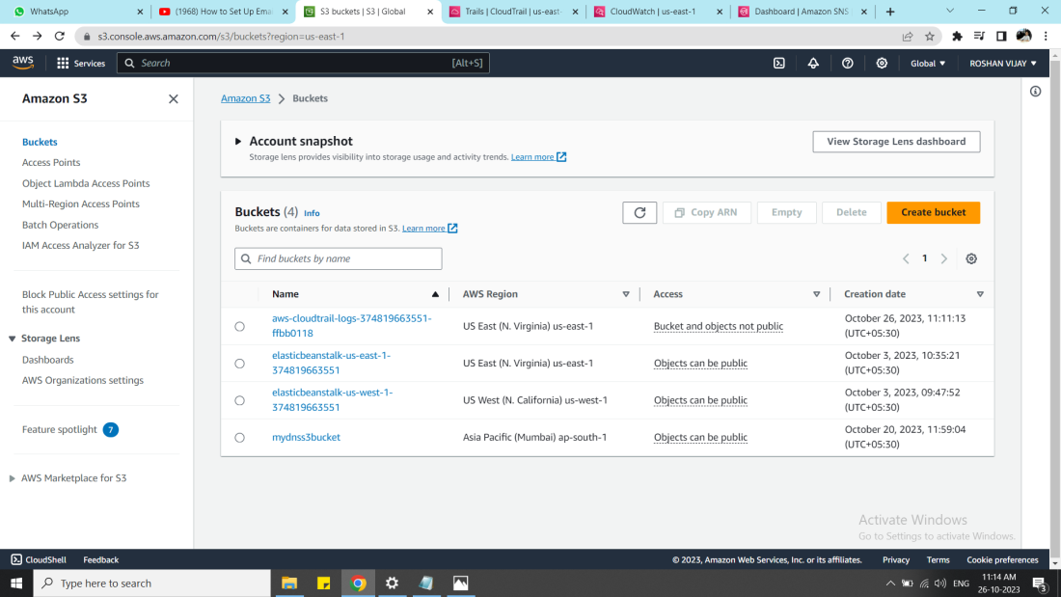

Step 7:

In the cloudwatch log groups, a new cloud trial log is created,it collects some log streams

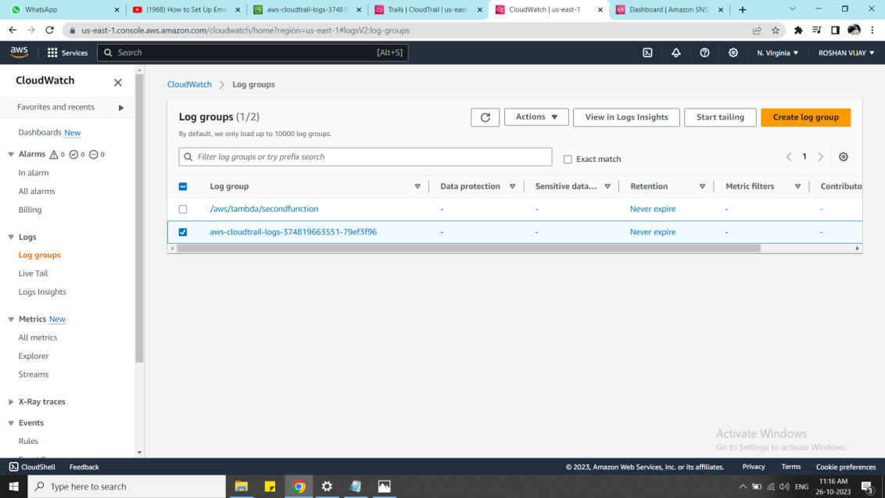

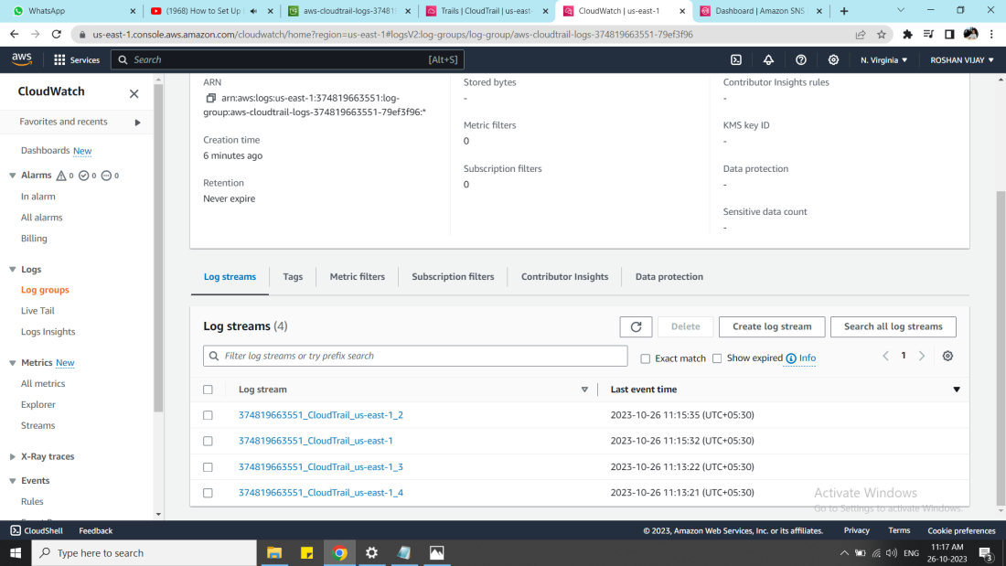

Step 8:

Go to cloud watch metric

cloudwatch log --> Actions --> create a metric filter -->metric filter condition -->next

with this metric filter condition,filter the log which matches the condition

**{ ($.eventName = DescribeLogStreams) && ($.recipientAccountId= "374819663551") }**

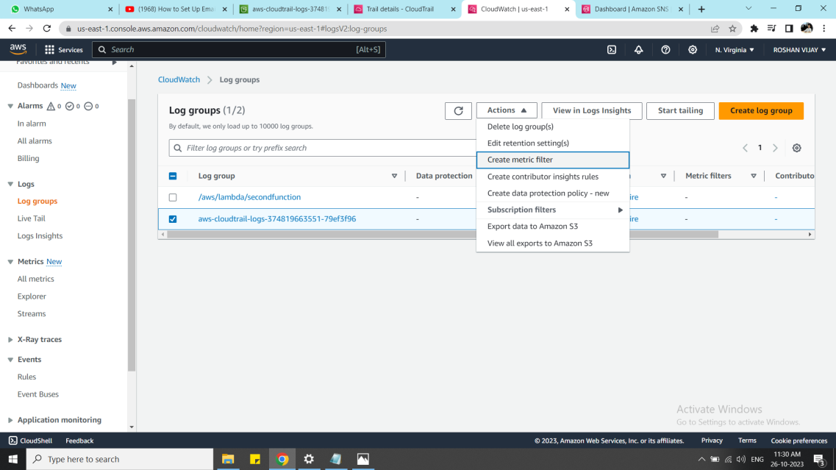

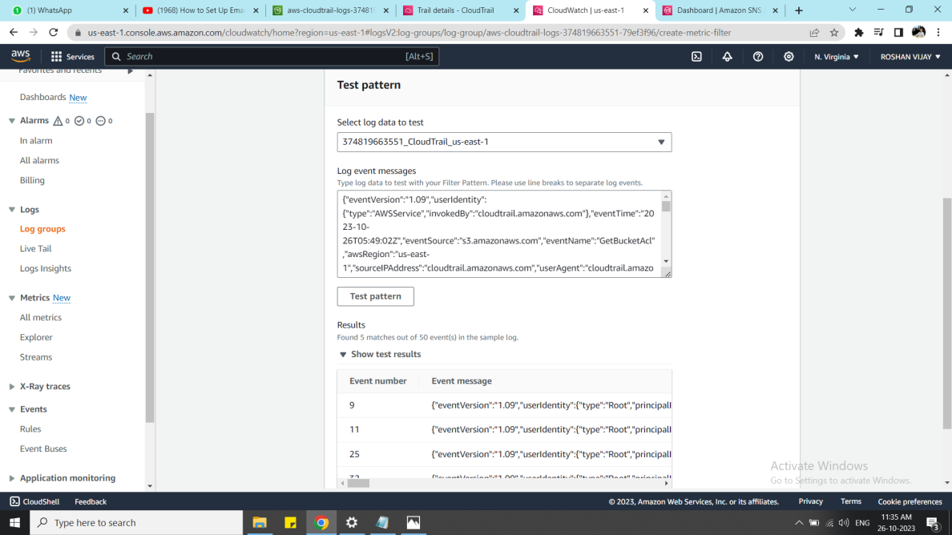

Step 9:

metric filter name --> metric name space --> metric name --> metric value-->next-->review and create

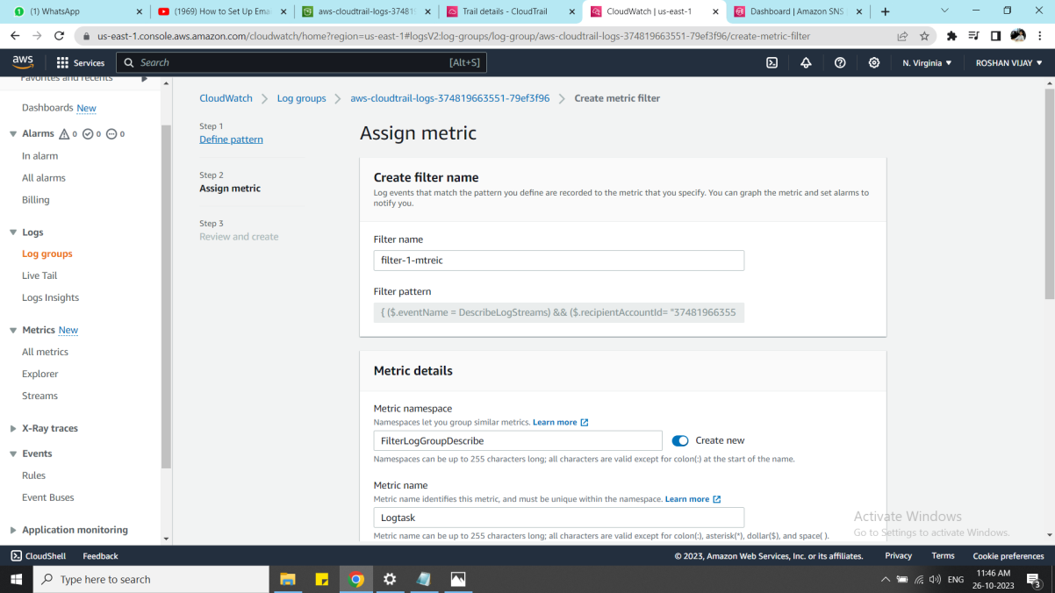

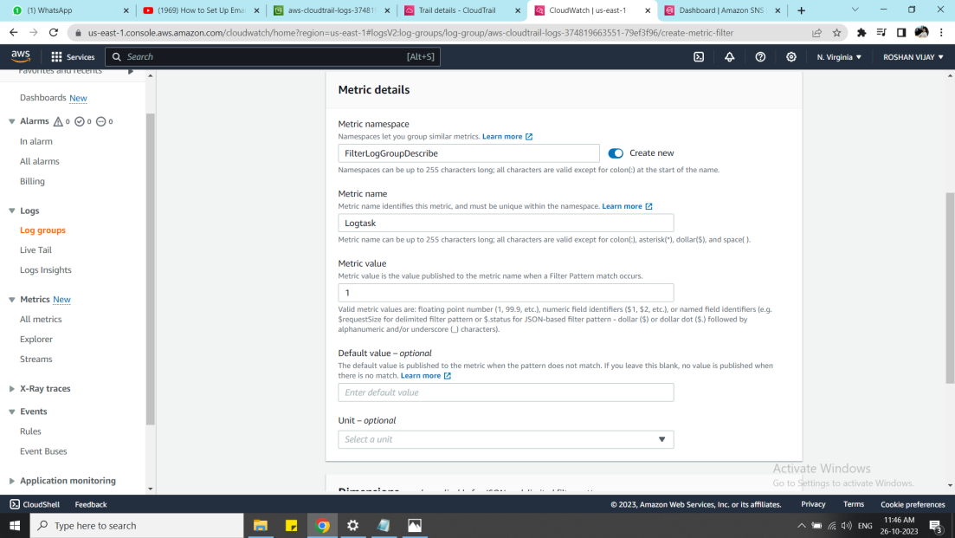

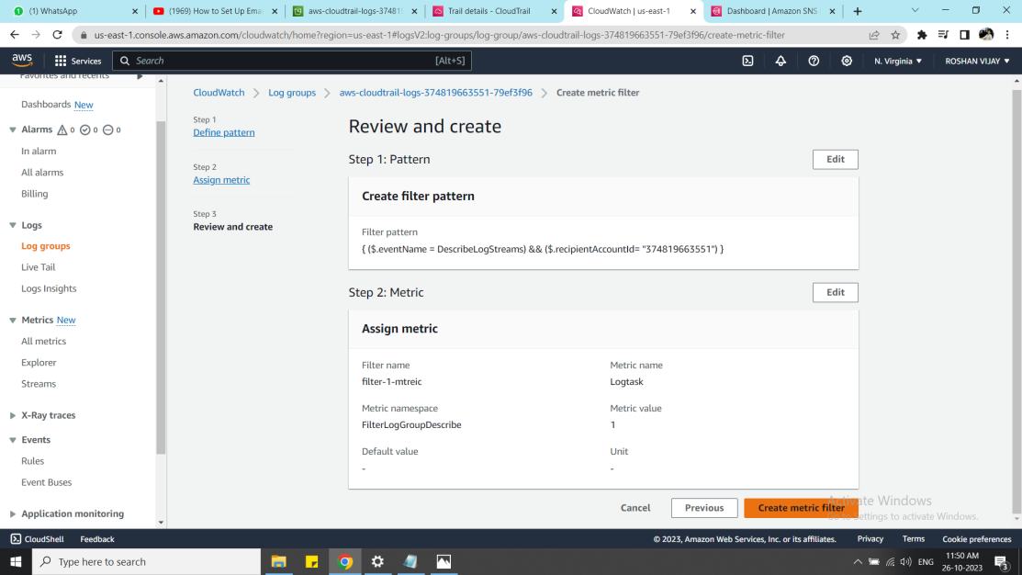

Step 10:

We have configured the metric filter.

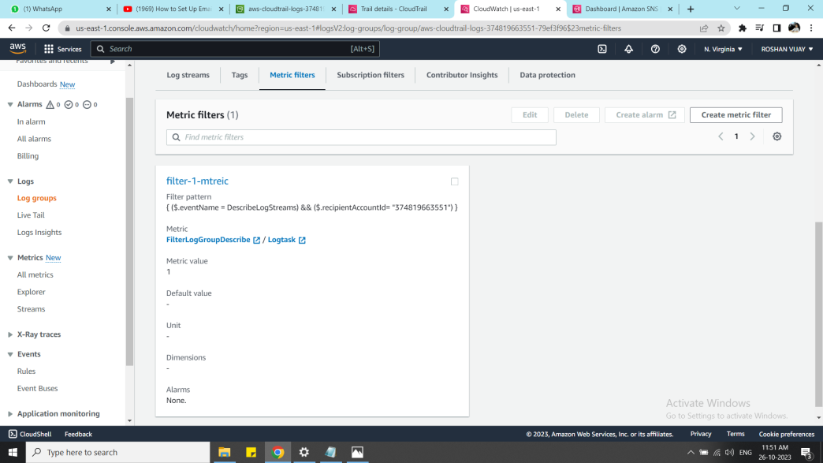

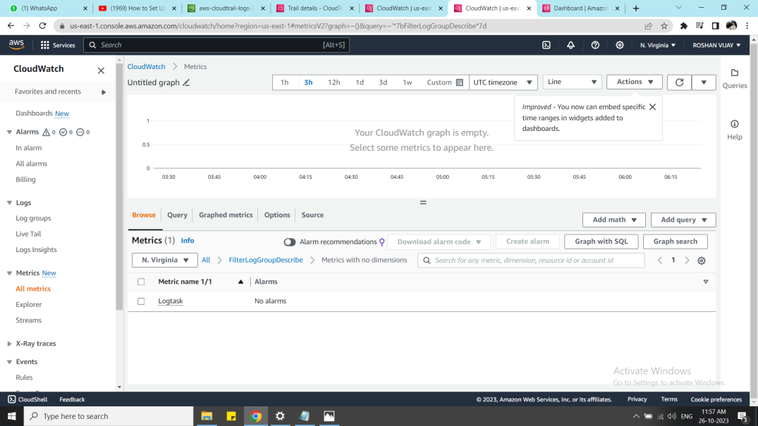

Step 11:

Next goto the cloudwatch alarm and create the new alarm

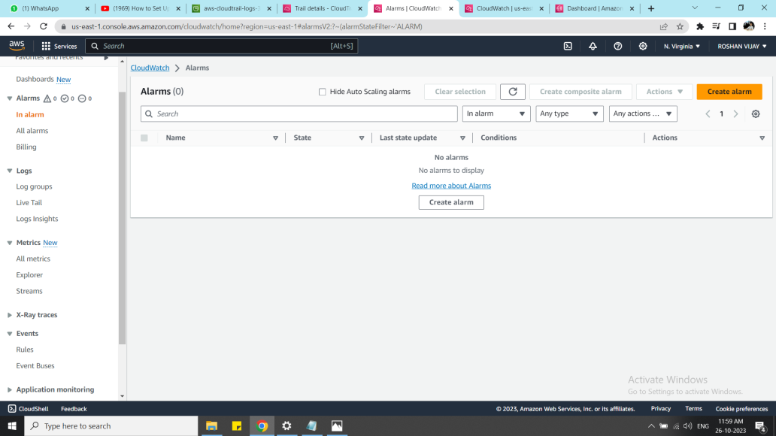

Step 12:

select metric --> in the metric section,select the time period to 10s

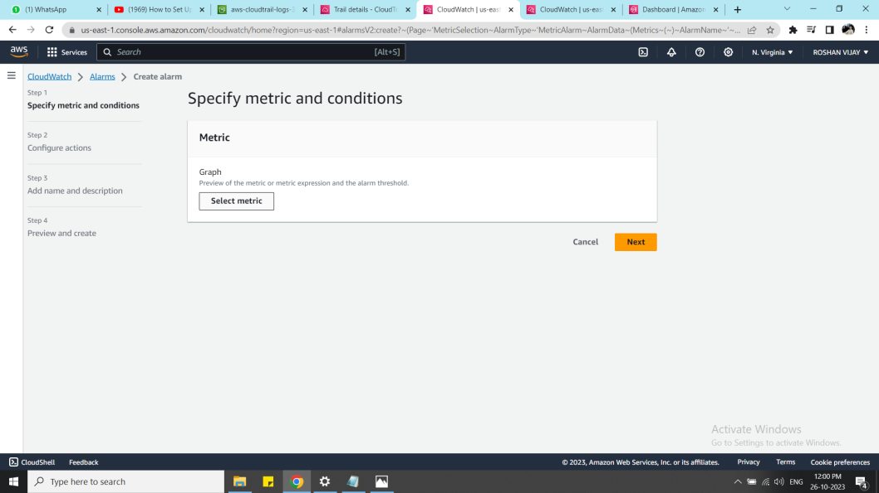

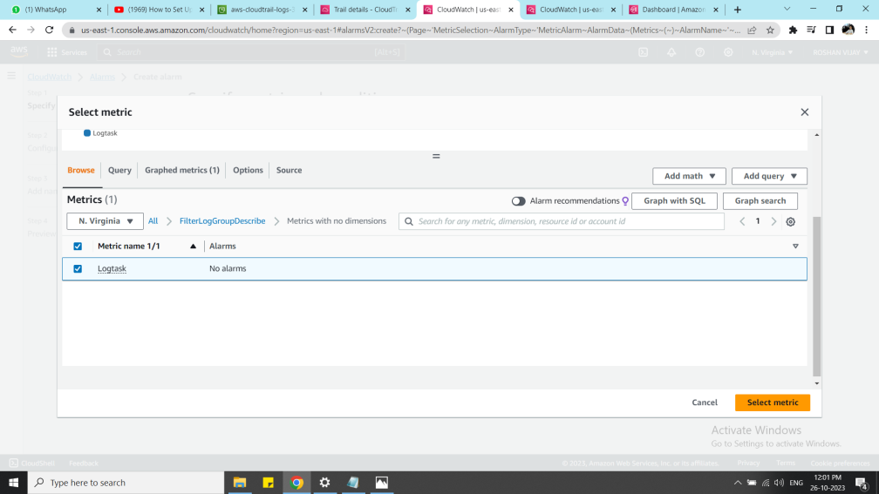

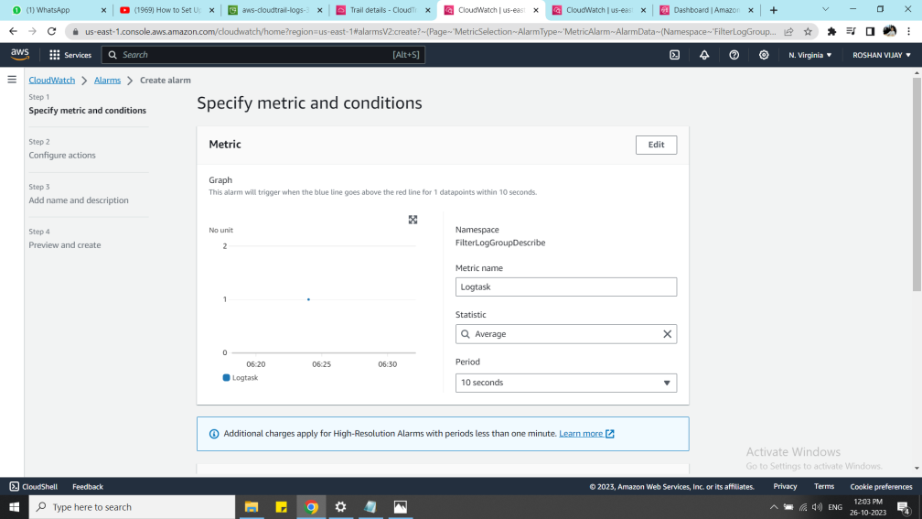

Step 13:

in conditions select the threshhold type as static and greater than 0 --> next

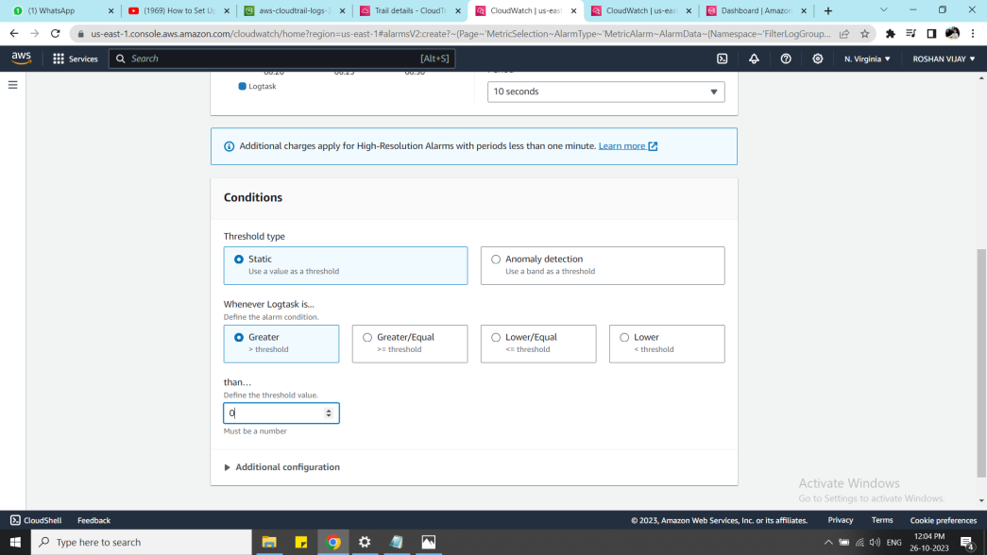

Step 14:

In the configure notification tab, alarm state trigger --> In alarm -->SNS topic --> create a new topic --> add the user email-id --> create topic

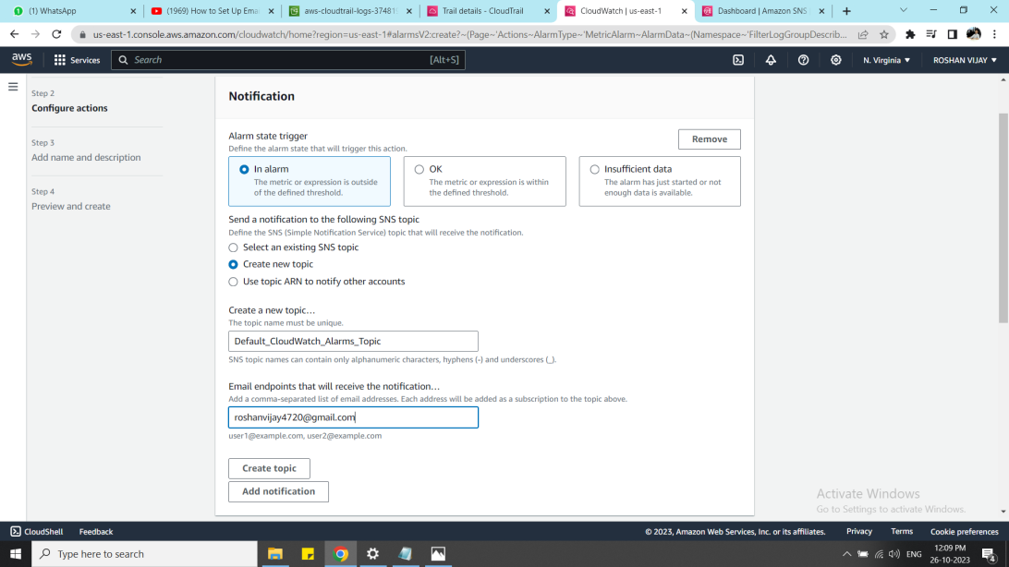

Step 15:

now check the email inbox and confirm the subscription

now new SNS topic has been created

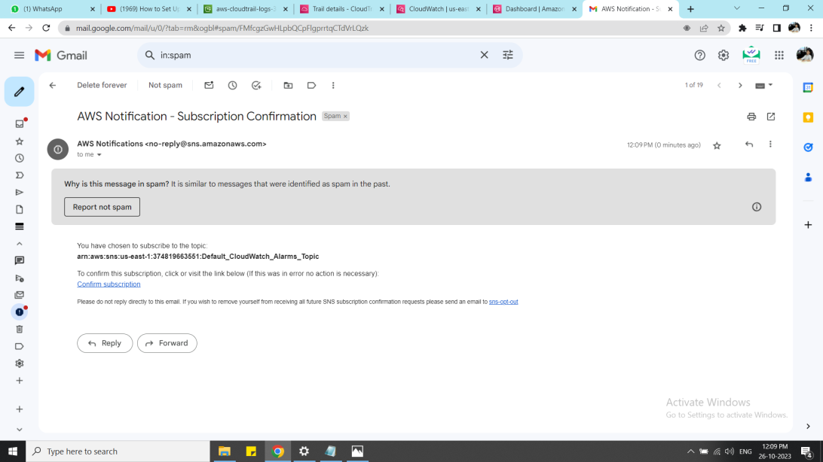

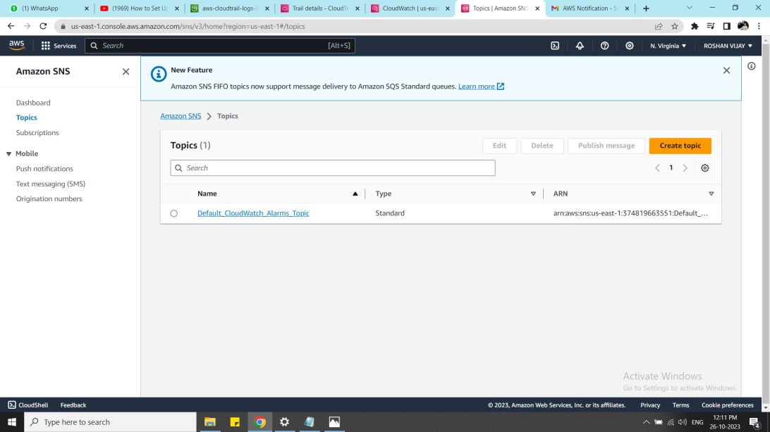

Step 16:

Add the alarm name and customize the notification message and review the alarm configuration and create alarm

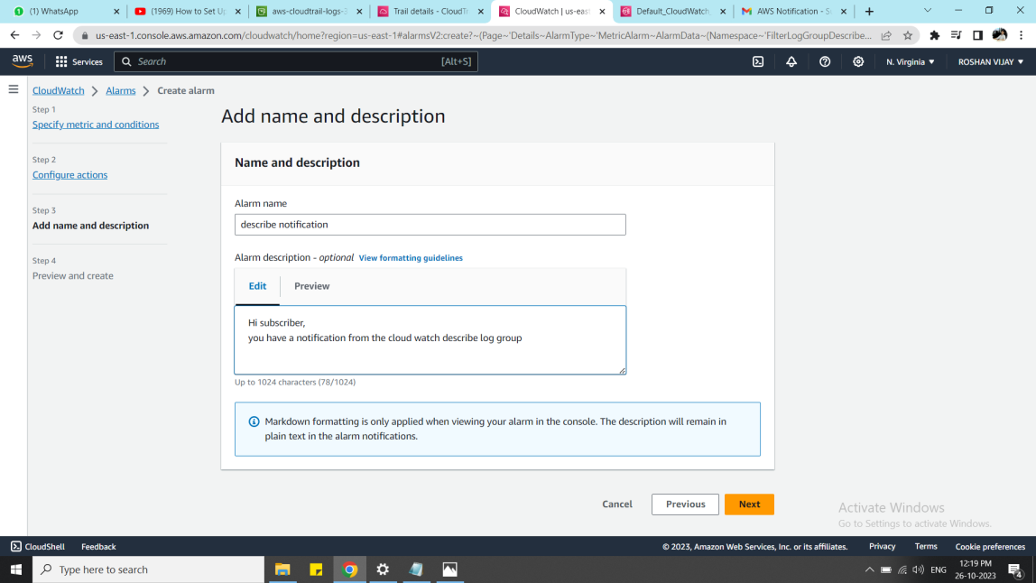

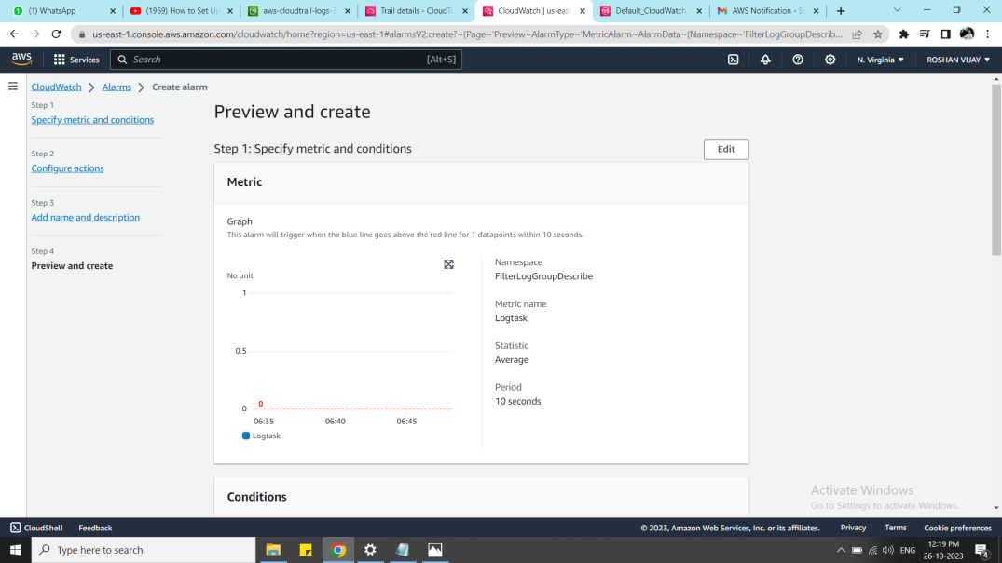

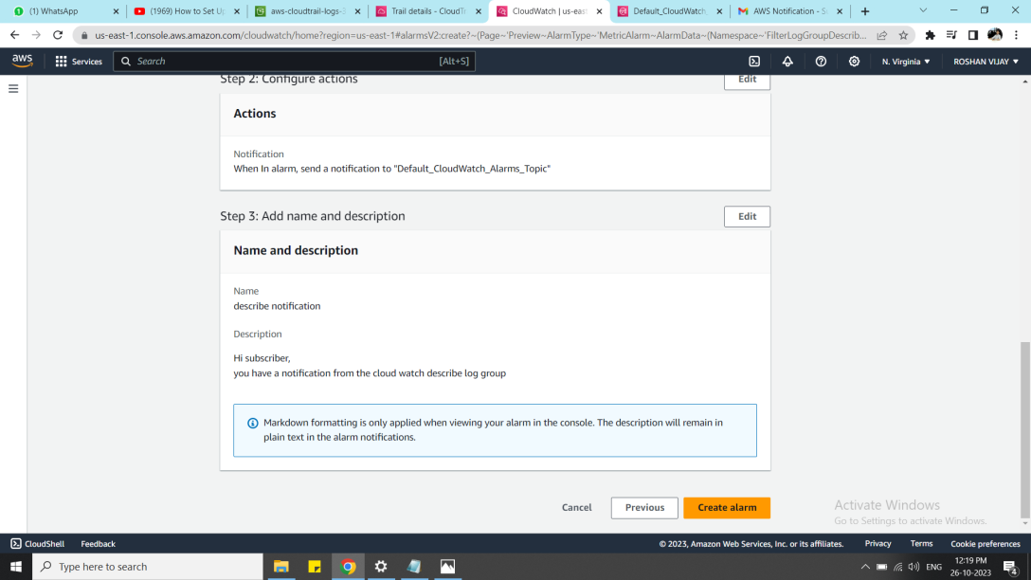

Step 17:

Now go to the cloud Trial Event history and check whether the log configured is started creating the logs

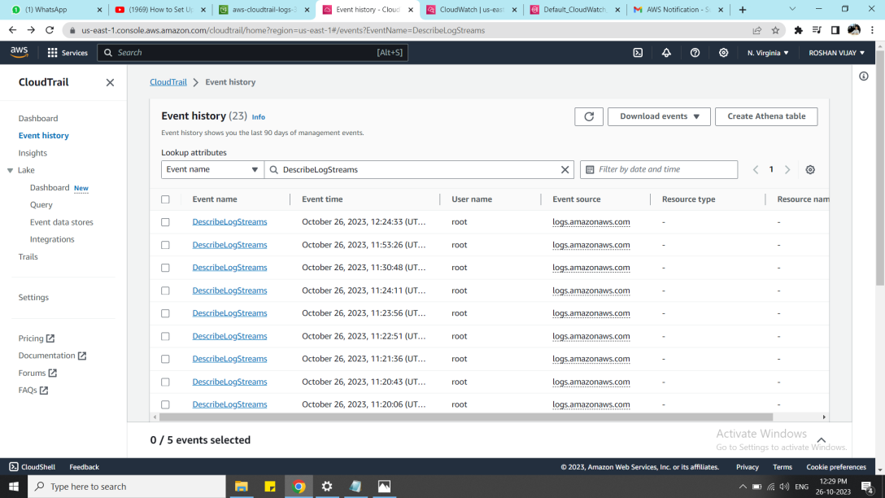

Step 18:

In the cloud watch alarm, check the alarm history changes, and now the notification email will be dropped in the inbox

